**• Make a web page that does a GET for a sensor value (any value of type integer) e Make a database of any type • Make a web page that stores the sensor's value in the database table**

**• Website Page**



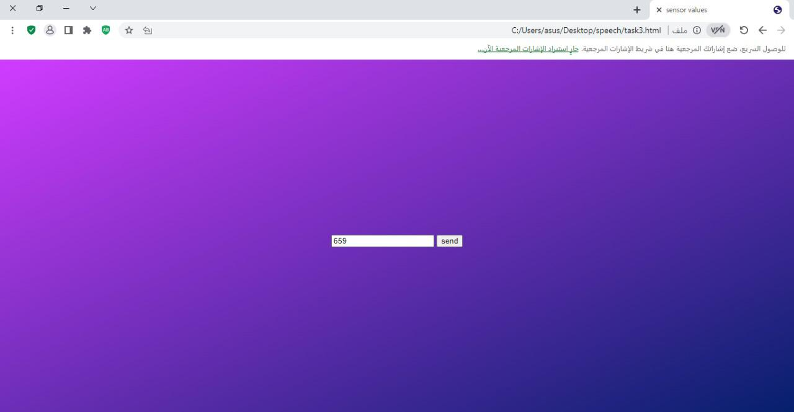• Before Pressing The Send Button

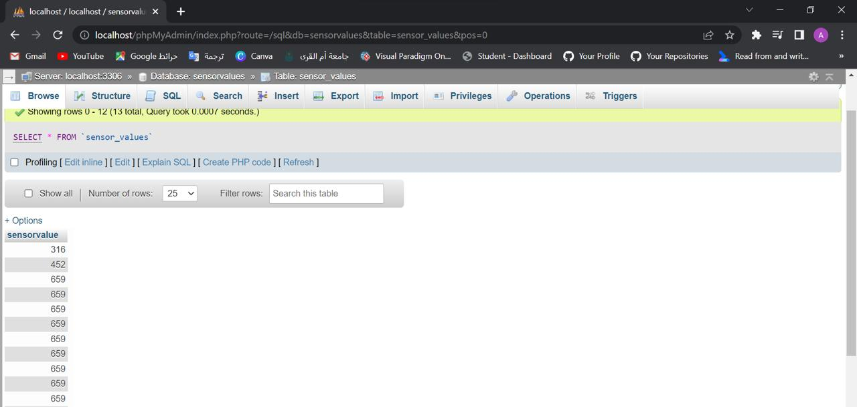• After Pressing The Send Button

 The Send Value Will Be Saved The Database